Atoms:DS Tutorial

Screen 1 - Intro
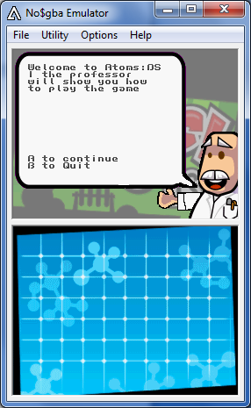
Text:
Welcome to Atoms:DS I the professor will show you how to play the game

Action:
A to continue to next screen
B to quit.

Screen 2 - Place Atom
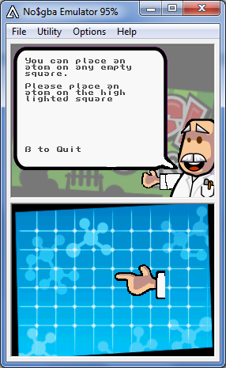
Text:
You can place an atom on any empty square
Please place an atom on the high lighted square

Action:
The player places an atom next to the arrow, the atom will grow and then change to the next screen.

Screen 3 - Grow Atom
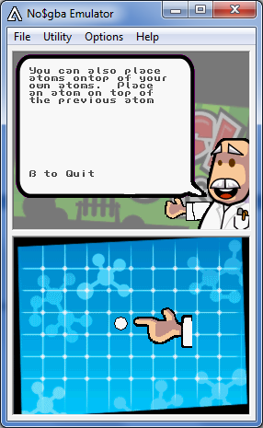
Text
You can also place atoms ontop of your own atoms. Place an atom on top of the previous atom

Action
The player will place a second atom on the first one, which will grow to the second size.

Screen 4 - Show the critical sizes
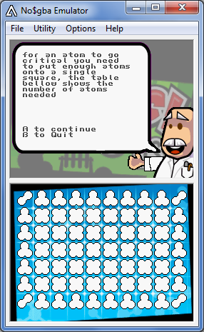
Text:
for an atom to go critical you need to put enough atoms onto a single square, the table bellow shows the number of atoms needed

Action
Player presses A to continue.

Screen 5 - Going critical
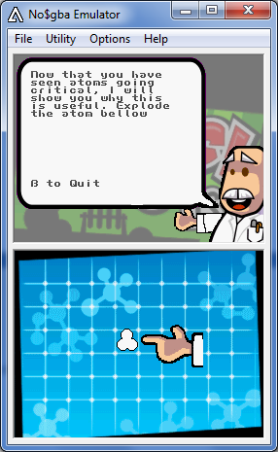
Text:
When an atom goes critical it will send atoms horizontal and virtically away from it, explode the atom bellow

Action:
The player puts an atom on the atom to make it go critical, which will send out atoms.

Screen 6 - capture atoms
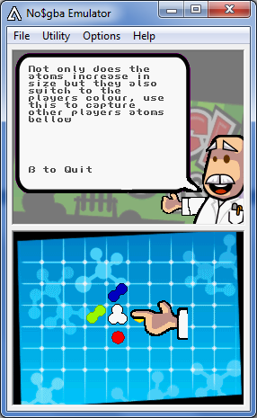
Texts:
Not only does the atoms increase in size but they also switch to the players colour, use this to capture other players atoms bellow

Action:
Player places atom on the atom which will explode the atom and capture the other 4 atoms.

Screen 7 - Chain explostions
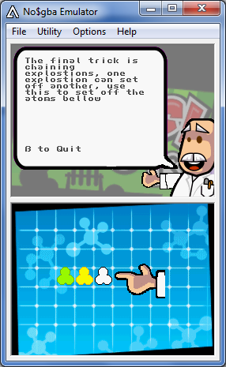
Text:
The final trick is chaining explostions, one explostion can set off another, use this to set off the atoms bellow

Action:
Player will place an atom on the highlighted square this will explode and set off the other atoms .

Screen 8 - Swinging the game
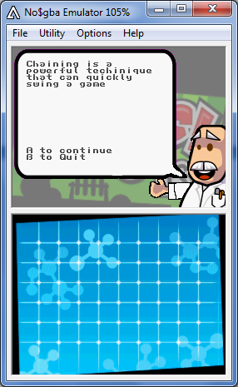
Text:
Chaining is a powerful techinique that can quickly swing a game

Action
Player presses A to continue

Screen 9 - How to Win
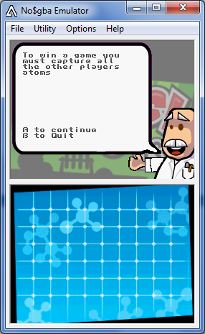
Text:
To win a game you must capture all the other players atoms

Action:
Player will press A to continue

Screen 10 - End
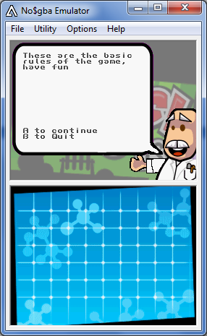
Text:
These are the basic rules of the game, have fun

Action:
Player will press A to finish.

